21LEM302T- INDIAN TRADITIONAL KNOWLEDGE
A PROJECT REPORT
Submitted by

Raghav Menon [RA2211003011027] Ayush Kumar [RA2211003011048]
Harsh Mehrotra [RA2211003011060]

Under the Guidance of
Dr. M. Kandan
Assistant Professor, Department of Computing Technologies

in partial fulfillment of the requirements for the degree of

BACHELOR OF TECHNOLOGY
in

COMPUTER SCIENCE AND ENGINEERING

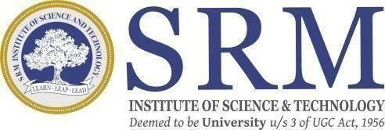

DEPARTMENT OF COMPUTING TECHNOLOGIES COLLEGE OF ENGINEERING AND TECHNOLOGY SRM INSTITUTE OF SCIENCE AND TECHNOLOGY KATTANKULATHUR– 603 203
APRIL 2025

Timeline of the great astronomers and mathematicians
